**HTML LINKS**

* **Hyperlinks** are used to link different web pages together or link different parts of a web page.
* It is represented as **<a> … </a>.** It is known as the **anchor tag**.
* The anchor tag has the href attribute which stands for **Hypertext Reference** which consists of the address of the link’s destination.
* **Syntax** : <a href = ” link address” > LINK NAME </a>
* Links are of two types :

1. **Absolute links** : It consists of an entire address specified using https.
2. **Relative links** : A local link (a link to a page within the same website) is specified with a ****relative URL**** (without the "https://www" part).

This is the code:

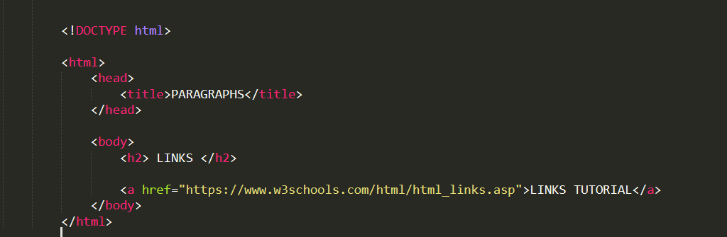

This is how the web - page looks:

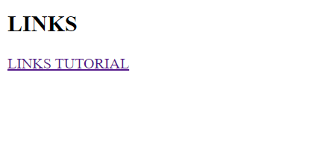

The output when the link is clicked.

